IRB Order of Operations Flowchart

This document includes the basic details regarding what human subjects research is and how the IRB submission and review process works. This document is meant to be used as guidance for researchers to assist in the thorough completion of an IRB submission from start to finish.

It is recommended that this document be consumed in full, as needed. Please utilize the search function for keywords or phrases to jump to specific information, as applicable.

If there is any question that is not answered within this document, please email IRB@gmu.edu
Is my project research?
Definition of research: a systematic investigation, including research development, testing and evaluation, designed to develop or contribute to generalizable knowledge. Activities which meet this definition constitute research for purposes of the federal policy, whether or not they are conducted or supported under a program which is considered research for other purposes. For example, some demonstration and service programs may include research activities. Classroom projects, quality improvement projects do NOT meet the definition of research
Classroom project SOP: SOP_1.3.5_Classroom-projects-1.pdf (gmu.edu)

Definition of human subject: a living individual about whom an investigator conducting research obtains (1) data through intervention or interaction with the individual, or (2) identifiable private information about whom includes a subject’s opinion on a given topic.

BOTH of the above must be true for the project to be considered human subjects research
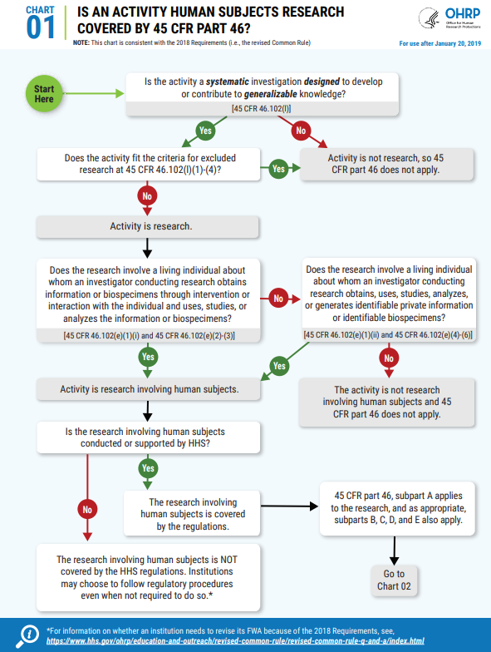
HHS decision charts: https://www.hhs.gov/ohrp/sites/default/files/human-subject-regulations-decision-charts-2018-requirements.pdf

My project is research…now what?
Required Training:
All researchers who will be involved in the research process, including the consent process, data collection, analysis of identifiable data, and/or will have access to identifiable data is required to complete the CITI Basic training course, either Group 1 for Social & Behavioral research or Group 2 for Biomedical research.
To complete CITI Basic training, follow the instructions on our website: Human Subjects Training - Office of Research Integrity and Assurance (gmu.edu)
To access the CITI website directly: Research, Ethics, and Compliance Training | CITI Program
If any researcher on the study team has already completed the Basic training at another institution, we can accept a copy of that report as long as it is current. Be sure to attach a copy of the training report to the IRBNet package.
Note: we do NOT accept the Responsible Conduct of Research (RCR) training.

Principal Investigator (PI):
All human subjects research conducted at GMU requires a full-time faculty member to be serve in the role of Principal Investigator (PI). Please refer to the following link to review the university policy: https://universitypolicy.gmu.edu/policies/principal-investigators/

Review System: IRBNet
We review all studies through IRBNet.org. This is where the application form is located, the consent template, and other relevant documents that may be required during the application process. This is also how we communicate with researchers during the review process and where we publish approval letters.
You will need to create an IRBNet account and affiliate with George Mason University: https://irbnet.org/release/home.html
Be sure to activate your IRBNet account once you create your username. The site will send an activation email to the email used to create the account, so be sure to click the activation link to get your account up and running properly.
Once you create a new project, you will complete the prompts on IRBNet to fill in the study title, faculty PI, and then go to the Designer page to download the application form and other relevant forms.
Download the application form and complete it in full. The guide for how to complete the application form is in a separate document.
Use consent template that is on IRBNet to create your consent form. Be sure to remove the instructions and template language/prompts before attaching it to the package. The document that is attached for the IRB to review should only include the consent that will be given to participants.
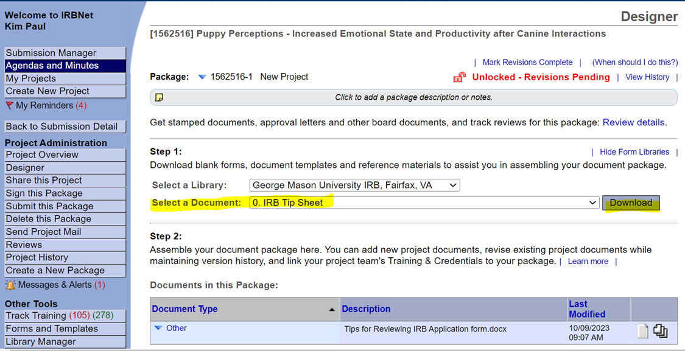
Attach the completed application, consent form, recruitment material, instrumentation that will be used, etc. to the package. Once all of the documents are attached, share the package with the PI. Then, ask the PI to electronically sign the IRBNet package before the project is submitted for IRB review. Once the package has been signed by the PI, click the Submit this Project button on IRBNet to submit the project to the IRB for review.
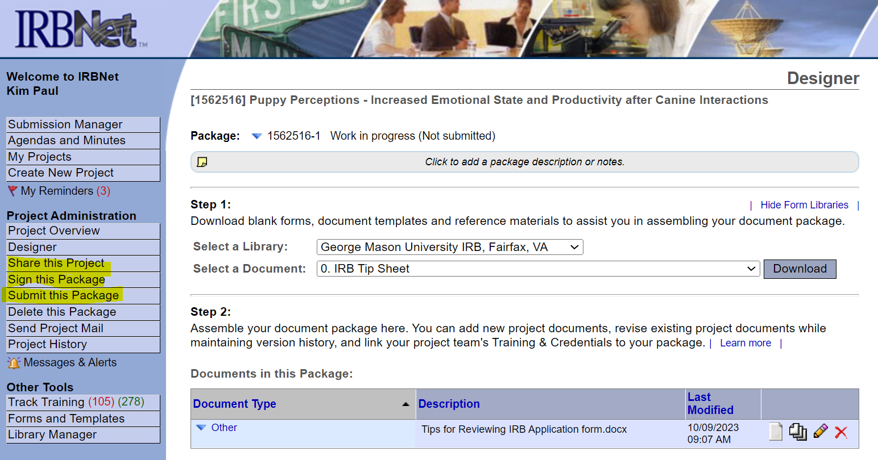
The submission should go to the IRB (defaulted in IRBNet), and then use the Submission Type drop-down menu to select the applicable submission type (i.e., New Project, Amendment, etc.).

Review Process
Once the project is submitted for review, the IRB Compliance Specialists will conduct a preliminary review of the submission within 10 business days. Once the project receives a preliminary review, the project will be “unlocked” with requests for clarifications and/or additional information that is needed. The communication for these requests takes place via IRBNet’s messaging system. You will be notified via the email addressed used to create your IRBNet account that your package has been unlocked, but the list of requests will only be accessible in IRBNet.
To access the message with the requested revisions in IRBNet, click on the Messages & Alerts text on the left side of IRBNet. Then, click on the blue Package Unlocked text under Message type to open the message.
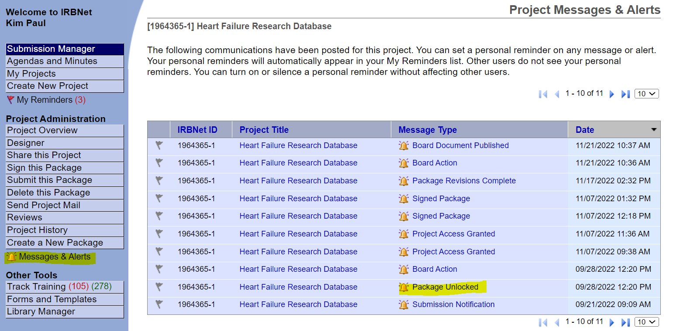
Once modifications are made to required documents, you will remove old versions of the documents from the package and attach the updated versions instead. Once everything has been addressed, click Mark Revisions Complete at the top of the Designer page on IRBNet to “re-lock” the package. This step is the only way to notify the IRB staff that revisions have been made and are ready for review again.
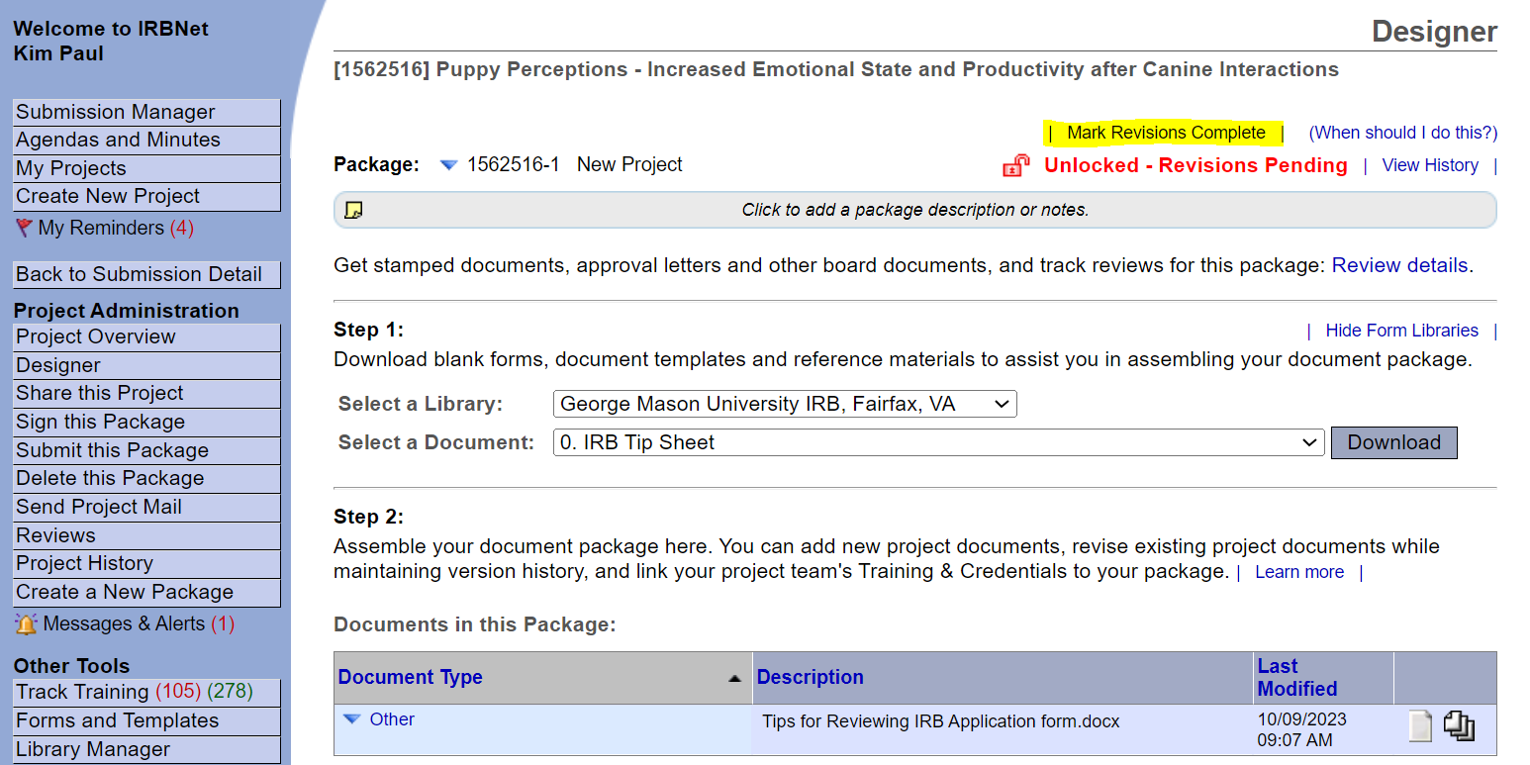When the package is re-locked with the changes made, another review will be conducted to ensure that the revisions were made correctly, generally within 10 business days of re-locking. There may also be additional requests following the preliminary review depending on the updated information received during the preliminary review. If there is another round of revisions needed, the same steps as above regarding the re-locking process should be followed.

Please note that there will be one IRB compliance specialist assigned to help facilitate the review of an IRBNet submission. It is recommended that any specific questions during the review are directed toward the specialist on the project, as they will be most familiar with your submission.

To access approved documents with the IRB stamp and decision letters, click on the Project Overview page, then click Review Details. Once in the Review Details section, you will be able to access Board Documents (i.e., stamped documents and letter(s)).
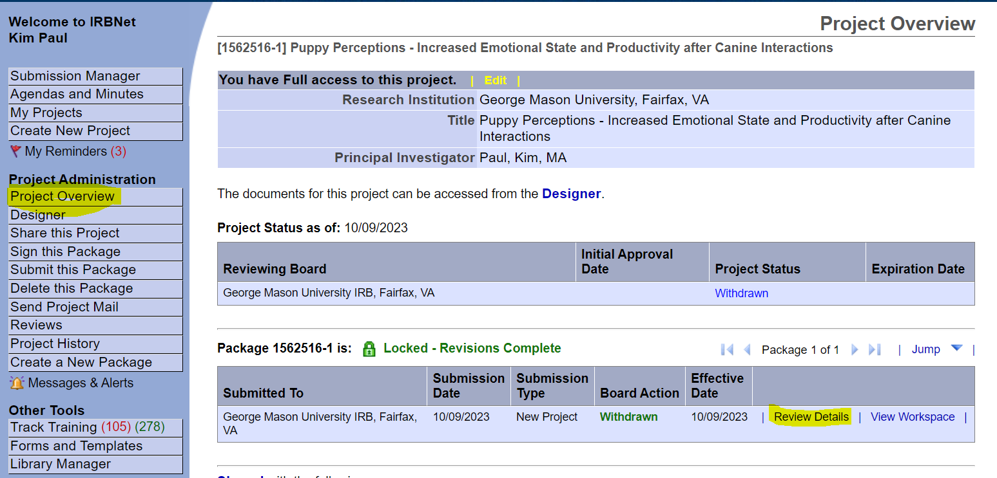
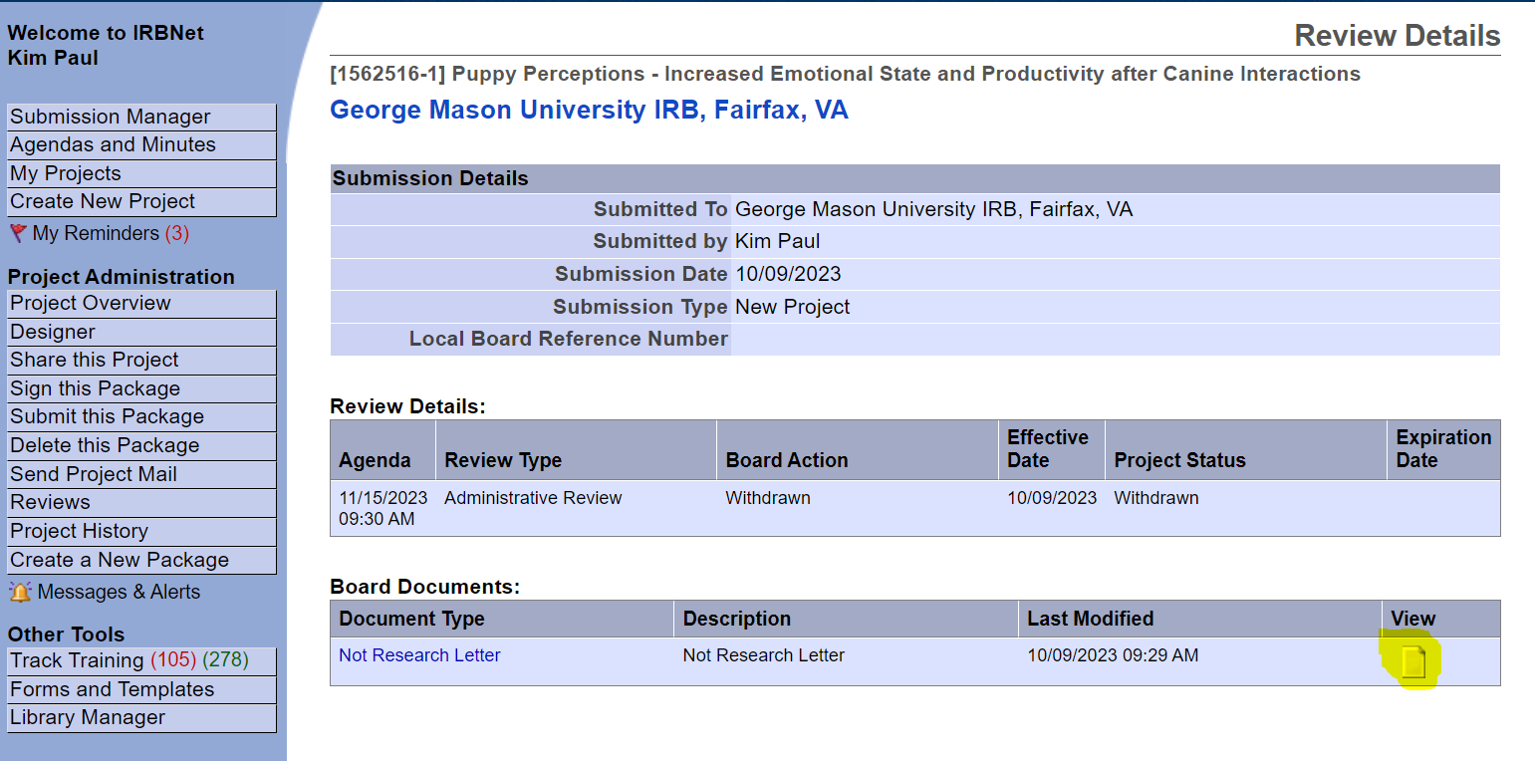
The submission deadline (https://oria.gmu.edu/topics/human-subjects/irb/meeting-schedule/) is for studies that may require review by the full board. We accept submissions on a rolling basis, and the majority of submissions do not require full board review (i.e., they can be submitted any time, regardless of the submission deadline posted on our website). However, if your study involves prisoners, FDA regulated drugs or devices, more than minimal risk to participants, the use of a DEXA scan, etc., then the submission deadline should be considered to ensure that your study is eligible for the next IRB meeting.

Generally, the entire review process takes between 4-6 weeks for an exempt or expedited study, 4-10 weeks for full board studies. The duration of the review process depends on the quality and completion of the application and materials submitted and how quickly / accurately revisions are addressed.

If there is a tight funding deadline, communicate that with us ahead of time. Submit a high-quality application/submission to reduce the amount of back and forth. We review submissions in the order that they are received.
Levels of Review
Not Research: The project does not meet the definition of either research or human subjects, therefore no IRB review is required. This does not mean that you cannot conduct the procedures; rather, this simply means that no IRB oversight is required so the IRB office will not review the protocol.
Exempt: The IRB office makes this determination. Exemptions (2018 Requirements) | HHS.gov
Expedited: At least one member of the IRB reviewed the submission and the protocol must fit into at least one of the expedited categories. OHRP Expedited Review Categories (1998) | HHS.gov
Full Board: The study was reviewed at one (or more) convened IRB meeting with its members voting on the approval of the protocol.
My project has been approved but I need to make changes…how do I do this?
Amendment Process
If there are any changes to the study design, instrumentation, consent and/or recruitment language, funding, study personnel, etc., an amendment will need to be submitted for review and approval before implementation of those changes.
To submit an amendment, click on Create a New Package on the left side of the page on IRBNet when in the project that you wish to make changes to. This will create a new package (making the IRBNet number end in -2 to indicate that it is the second package).
The process for submitting and reviewing an amendment are similar to the original process to submit a new project. The amendment form is in IRBNet and will need to be included in each amendment submission in addition to tracked changes and clean versions of any document that is being revised. The PI will also need to sign off on the amendment package before submitting for review.
Please refer to the amendment instruction document for step-wise instructions on submitting an amendment.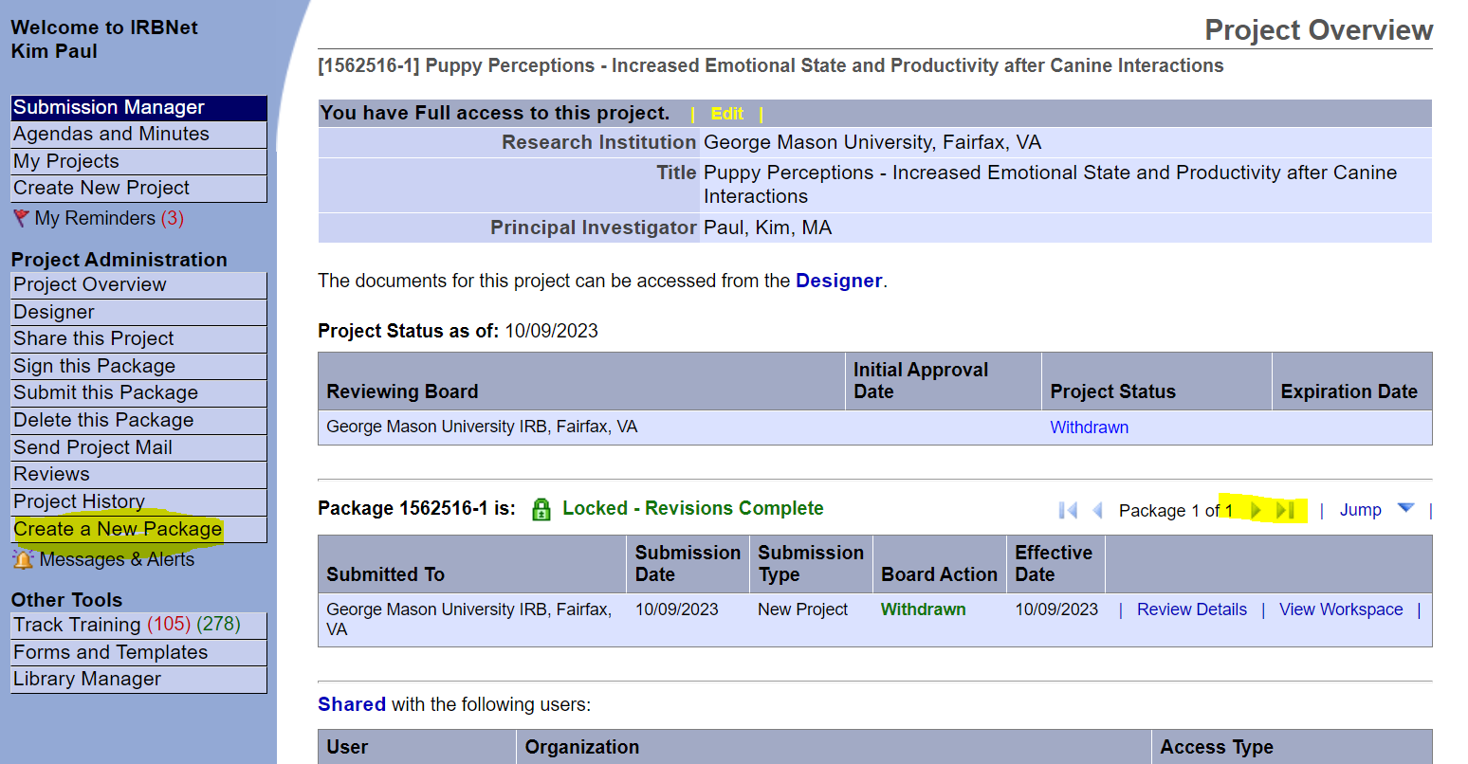
To navigate between packages in the future, go to the Project Overview page and use the blue arrows in the middle of the page to switch between each package.

Contact Us
We are available for questions and/or meeting requests via email at irb@gmu.edu

Contact Us - Office of Research Integrity and Assurance (gmu.edu)

Sarah Clark, CIP
Director, Human Research Protection Program
Phone: 703-993-6801
Fax: 703-993-9590
sclark68@gmu.edu
Kim Paul, CIP
IRB Compliance Manager
Phone: 703-993-4208
Fax:703-993-9590
kpaul4@gmu.edu
Michelle Wallerstedt Hodge
IRB Compliance Specialist
Phone: 703-993-9628
Fax: 703-993-9590
mwallers@gmu.edu
Haley Lint
IRB Compliance Specialist
Phone: 703-993-4121
Fax: 703-993-9590
hlint@gmu.edu
Brett Restrick
IRB Compliance Specialist
Phone: 703-993-1067
Fax: 703-993-9590
brestric@gmu.edu

